Model 3448 Comfort Station
Dimensions 34” Wide x 48” Long 81” High
Custom Dimensions Available
(Patents Issued and Pending)

Model 3448 also eliminates the need to construct bathrooms for your employees and then dismantle them to build the bathrooms for your customers.

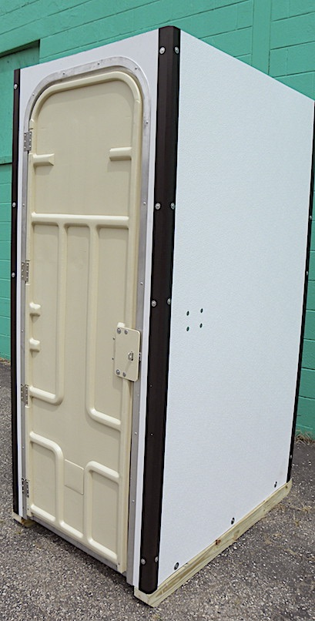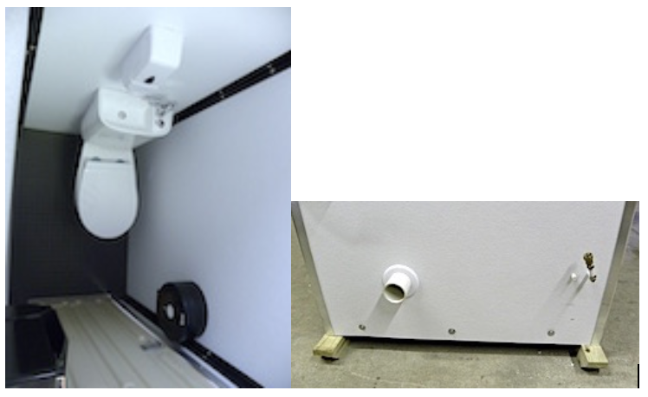
Exterior Front View Top Interior View Rear Exterior View

Rear Wall Plumbed Attachments

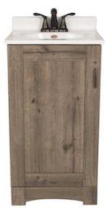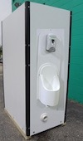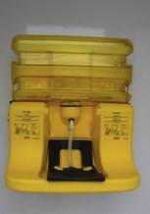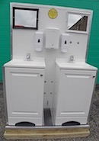
18” Vanity Waterless Urinal Eye Wash Hand Wash
Hand Sanitizer Station Station

Model 3448 comfort station was specifically developed for multistory construction projects that have size restrictions. The units can be loaded on their side in the freight elevator.
Standard Features

Ceramic Toilet and Sink Combination – 9” Toilet Tissue Dispenser – Paper Towel Dispenser – Mirror – Waste Basket – Supply of Consumables – Heavy Duty Door With Indicator Usage Lock - Aluminum Corners – ½” Fluted FRP Sheet Pebbled on Both Sides and Graffiti Resistant – Treated Wood Runners – Treated Plywood Floor – Coin Vinyl Flooring – Mobility Via a Pallet Jack –
Foaming Hand Soap Dispenser – Aluminum Door Jamb – Stainless Steel Door Hinges – Smoke Detector – Double Clamshell Door

The Model 3448 is manufactured to be used on multiple projects with minimal maintenance required.

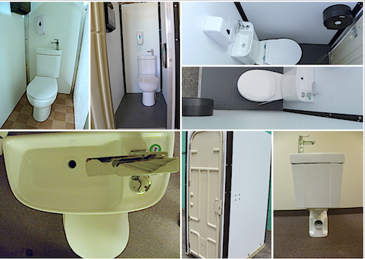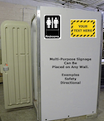
Multiple Model 3448 Views Walls can be used
for Signage
Options:

Model 3448 ships without a roof. Special attention will be paid to the height restrictions of the freight elevator on multiple story or underground projects. The 3448 height can be adjusted, or the unit can be tipped on its back.

Toilet and Sink and Faucet Choices

We offer several handwash system choices for the Model 3448 comfort station.

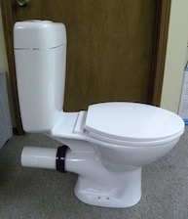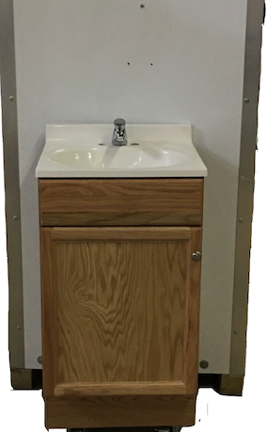
Fig 1. Fig. 2

Standard P-trap Toilet (above Fig 1.) and rear wall outside vanity (above Fig 2.) Vanity ships inside the Model 3448. The unit can be plumbed to the live water and sewer lines.

Cistern-Sink-Toilet Combination inside the Model 3448 allows us to custom design sanitation for most requirements.

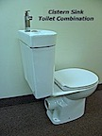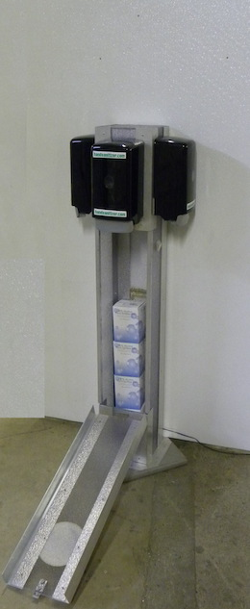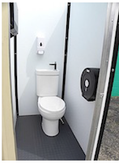
Combination Hand Sanitizer Front View of
Cistern and Sink Stand/Storage Model 3448

